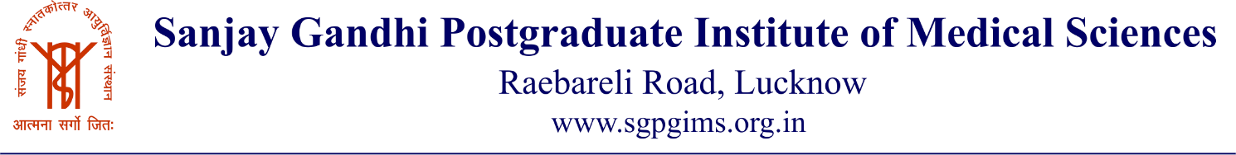
2.1 Reservation of seats of institute (programs where reservation is applicable)

Name of the Programs | Total seats | Total Reserved Seats | Admitted Reserved students
MD/MS | 76 | 43 | 32
MHA | 10 | 6 | 3
B.Sc.  (CMT) | 103 | 65 | 51
M.Sc.  (CMT) | 46 | 28 | 16
B.Sc  (Nursing) | 68 | 45 | 34
MSc  ( Nursing ) | 10 | 6 | 6
Total | 313 | 185 | 142

